**BRAILLE TRANSLATOR**

* Mitanshu Gupta (19116042)
* Pobbati Surendra (19116048)
* Sharma Vivek Gautam (19116068)
* Tanikonda Bhoomika (19116079)

***Abstract – Converting Braille letters and numbers to ASCII value.***

Keywords – 32 to 1 Multiplexer, BCD to 7 segment Decoder, 7 Segment Led display.

**INTRODUCTION**

After reading the description of this project we felt that this is the good project over others, since this could potentially be helpful tool to visually impaired people to overcome the challenges faced by them through effective communication.

**ARCHITECHTURE OF THE DESIGN**

Six inputs from Braille keypad were fed into Braille to BCD converter block which uses eight 32to1 multiplexers to give 8 outputs which are two BCD numbers (x3x2x1x0, y3y2y1y0) which are then fed into a block(Combinational circuit) which converts BCD to 7 segment display’s inputs as outputs, these outputs are fed into two 7 segment displays placed next to each other so now we finally gets a two digit ASCII values for Braille-ASCII inputs.

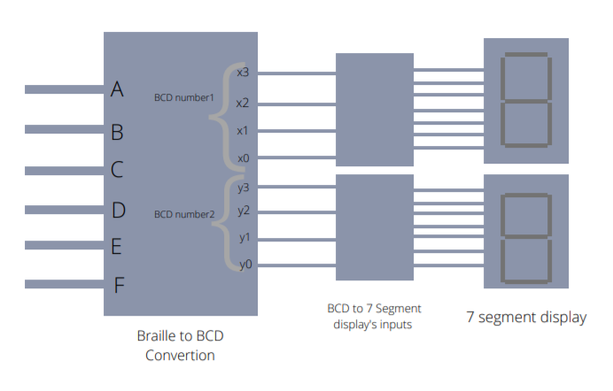

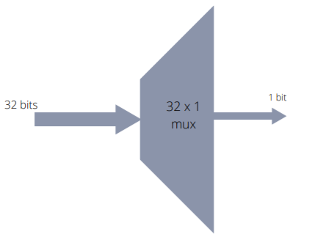Unit inside BCD to Braille converter

**CHALLENGES FACED DURING IMPLEMENTATION**

To convert six variables which form the dots of braille cells i.e. brille code to ASCII values we used K-map and made the behavioural design, but to change it to structural design we faced difficulty in formatting the design and then we dcame up with the thought of using multiplexer to reduce the complexity of the circuit. While designing we got some “invalid port expression errors” and that is because we have more number of port parameters and tried concatenating some of those parameters to a reg, but instead, concatenation should be done during instantiation of the module in the other module and number of port parameters should be reduced and even after solving this we have instantiated all the 4 to 1 multiplexers in the same module which isn’t a good way and we then changed the code by writing separate modules and created higher order multiplexers to make the code much easier and more understandable and finally got desired functionality.

**SIMULATION RESULTS**

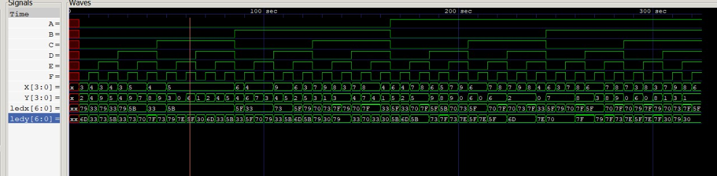

Inputs and outputs in wave form

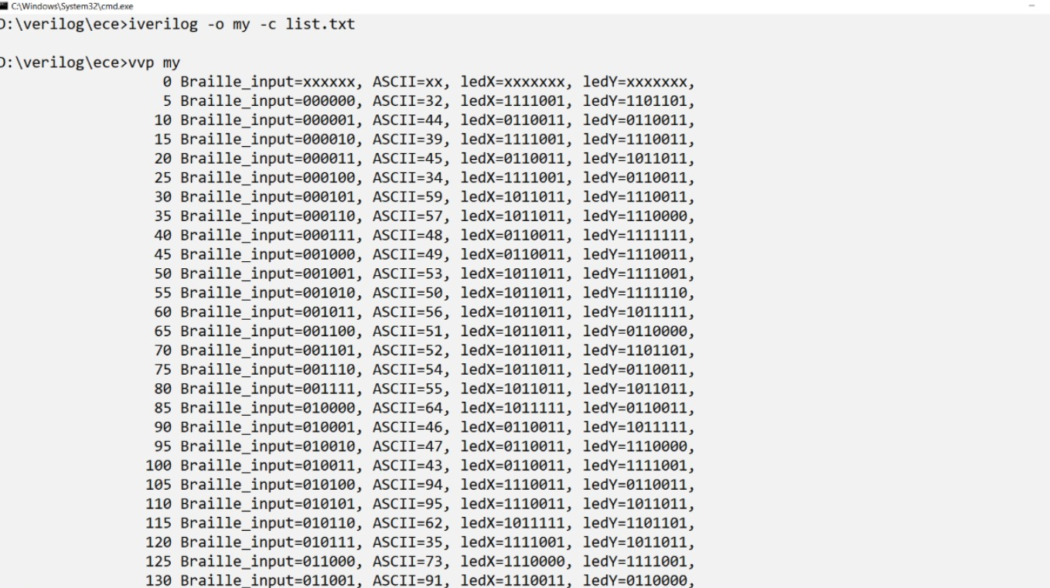

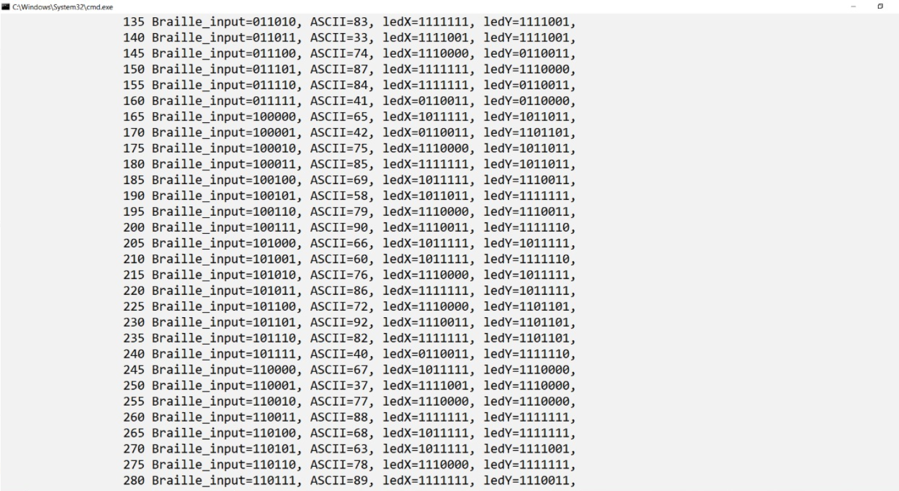

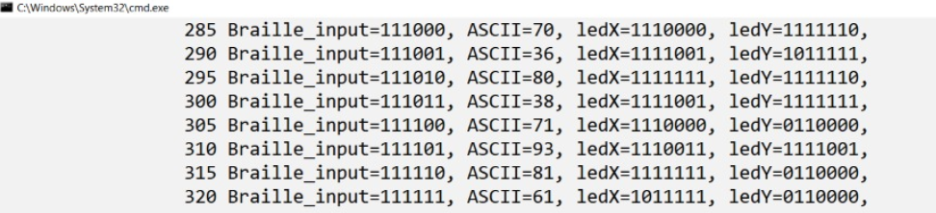

Braille inputs and outputs on 7 segment displays (in ASCII form)

**CONCLUSION**

Braille translator can potentially be helpful tool for visually impaired people to overcome the challenges faced by them through effective communication.

We have effectively learned the basics of Verilog modeling language by completing this project.

We tried using various procedures and with each successive procedure, we have managed to build up a hierarchy and reduce the complexity of design of our project.

To make this braille translator, we have created Verilog modules as the building block to convert braille notation into ASCII value.

References

1. <https://nptel.ac.in/courses/106/105/106105165/>

1. <https://www.ijareeie.com/upload/2016/april/165_MR151203_Megha_Paper_V1.pdf>
2. <https://drive.google.com/file/d/1jkPYPx7WrT_wz8sr40yl3MRmcs4WtSGf/view?usp=sharing>